Unit 3 – Lesson 7. Using SQL Joins – Practice 1
Aim:
What are the differences among the SQL joins? How do we use SQL joins more efficiently?

Objectives: After the lesson, students will be able to:
- Obtain basic understanding of RDBMS data structure and data relations
- Write SQL scripts that uses joins effectively

CLASS PROCEDURE:

Do Now: Open the saved session you worked on in class on yesterday. Now you shall have three tables:

STUDENS1:
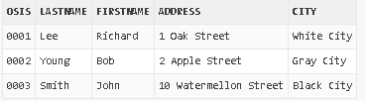

COURSES:
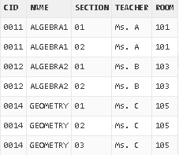

ST_COURSE:
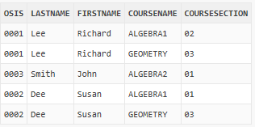

How do we write a query to display all of the students who are enrolled in Ms. C’s classes this year and show the following information?

Student Last Name, Student First Name, Course Section, Class Room, Student Address, Student City
Pair – sharing Activity #1:
The following practice question is actually taken from the real interview questions from amazon. Work with your partner and research on the answer of the questions.

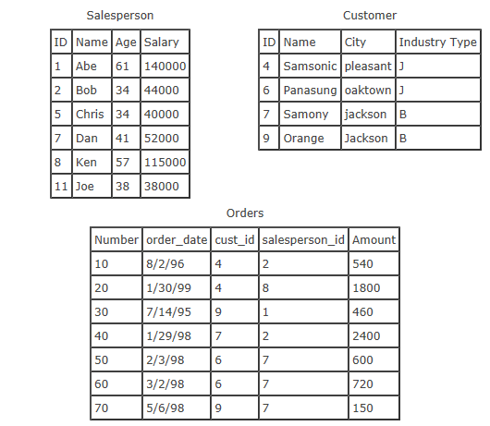

Given the tables above, answer the following questions:
- Write a SQL statement to return the names of all salespeople that have an order with Samsonic.

- Write a SQL statement to return the names of all salespeople that do not have any order with Samsonic.

- Write a SQL statement to return the names of salespeople that have 2 or more orders.

- Write a SQL statement to insert rows into a table called highAchiever (Name, Age), where a salesperson must have a salary of 100,000 or greater to be included in the table.

You may use online tutorial like http://www.w3schools.com/sql/ and/or Oracle Live SQL to research and test your solutions.

Solutions for previous practices:

- To create the 3rd table STCOURSE (STUDENT and COURSE):

CREATE TABLE STCOURSE
(
OSIS varchar(4),
LastName varchar(255),
FirstName varchar(255),
CourseName varchar(255),
CourseSection varchar(2)

);

INSERT INTO STCOURSE (OSIS, LastName, FirstName, CourseName, CourseSection)
VALUES ('0001', 'Lee', 'Richard', 'ALGEBRA1', '02');

INSERT INTO STCOURSE (OSIS, LastName, FirstName, CourseName, CourseSection)
VALUES ('0001', 'Lee', 'Richard', 'GEOMETRY', '03');

INSERT INTO STCOURSE (OSIS, LastName, FirstName, CourseName, CourseSection)
VALUES ('0003', 'Smith', 'John', 'ALGEBRA2', '01');

INSERT INTO STCOURSE (OSIS, LastName, FirstName, CourseName, CourseSection)
VALUES ('0002', 'Dee', 'Susan', 'ALGEBRA1', '01');

INSERT INTO STCOURSE (OSIS, LastName, FirstName, CourseName, CourseSection)
VALUES ('0002', 'Dee', 'Susan', 'GEOMETRY', '03');

SELECT * FROM STCOURSE

- To create a STUDENT1 table and insert some dummy records:

CREATE TABLE STUDENTS1
(
OSIS varchar(4),
LastName varchar(255),
FirstName varchar(255),
Address varchar(255),
City varchar(255)
);

INSERT INTO STUDENTS1 (OSIS, LastName, FirstName, Address, City)
VALUES ('0001', 'Lee', 'Richard', '1 Oak Street', 'White City');

INSERT INTO STUDENTS1 (OSIS, LastName, FirstName, Address, City)
VALUES ('0002', 'Young', 'Bob', '2 Apple Street', 'Gray City');

INSERT INTO STUDENTS1 (OSIS, LastName, FirstName, Address, City)
VALUES ('0003', 'Smith', 'John', '10 Watermellon Street', 'Black City');

INSERT INTO STUDENTS1 (OSIS, LastName, FirstName, Address, City)
VALUES ('0004', 'Dee', 'Susan', '10 Strawberry Street', 'Red City'));

SELECT * FROM STUDENTS1;

- To create the COURSE table:

CREATE TABLE COURSES
(
CID varchar(4),
NAME varchar(255),
SECTION varchar(2),
TEACHER varchar(255),
ROOM varchar(10)
);

INSERT INTO COURSES (CID, NAME, SECTION, TEACHER, ROOM)
VALUES ('0011', 'ALGEBRA1', '01', 'Ms. A', '101');

INSERT INTO COURSES (CID, NAME, SECTION, TEACHER, ROOM)
VALUES ('0011', 'ALGEBRA1', '02', 'Ms. A', '101');

INSERT INTO COURSES (CID, NAME, SECTION, TEACHER, ROOM)
VALUES ('0012', 'ALGEBRA2', '01', 'Ms. B', '103');

INSERT INTO COURSES (CID, NAME, SECTION, TEACHER, ROOM)
VALUES ('0012', 'ALGEBRA2', '02', 'Ms. B', '103');

INSERT INTO COURSES (CID, NAME, SECTION, TEACHER, ROOM)
VALUES ('0014', 'GEOMETRY', '01', 'Ms. C', '105');

INSERT INTO COURSES (CID, NAME, SECTION, TEACHER, ROOM)
VALUES ('0014', 'GEOMETRY', '02', 'Ms. C', '105');

INSERT INTO COURSES (CID, NAME, SECTION, TEACHER, ROOM)
VALUES ('0014', 'GEOMETRY', '03', 'Ms. C', '105');

SELECT * FROM COURSES;

